Website Copy
Antra Business Group Plc
Revision 2, rewritten for human voice
Prepared by WubSites

Home Page

Hero Section
Headline: Enabling Growth and Transformation
//Add video//
Subhead:
- We bring you best proven practices, deep cross-industry knowledge and global expertise to support and drive organizational transformation, backed by more than 20 years of corporate experience and a proved track record of excellence.
We are a management consultancy and a trading company based in Addis Ababa. Companies and institutions across Ethiopia work with us when they need to rebuild organization a leadership bench, sharpen how the business runs, or source equipment that is hard to find locally.
Primary CTA: Start a conversation
Secondary CTA: See what we do
//Add news: OVID’s contract with Antra
//Add meet our leaders: Include Anteneh Managing Director/PHD/ and NOVA business group

What we do
Omit Two practices. One partner.

Our areas of expertise include organizational leadership, strategy formulation and alignment, change and transformation management, leadership development, coaching and mentoring, training, and the translation of strategy into execution. We combine professional and academic excellence to ensure that our approach reflects both international best practice and Ethiopian institutional relevance.
Our trading division supplies equipment that cannot be easily sourced inside Ethiopia, from construction machinery, electric vehicles to medical equipment, through our operations in the Djibouti Free zone.

01 – Management Consultancy
Leadership, strategy, organizational transformation and people solutions
02- Trading and Supply
Directly from manufacturers via Djibouti free zone

Service Pillars

Management Consultancy
We work with executive teams on leadership development, organizational transformation, strategy, talent search, and coaching that helps senior people deliver on what they committed to. Most of our engagements run past the design phase into implementation, because that is where transformation work breaks down.
CTA: Explore consultancy

Trading and Supply
Our trading division sources and distributes electric vehicles, construction machinery, sanitary equipment, and medical equipment. Most shipments come through the Djibouti Free zone. Our buyers include fleet operators, contractors, hospitals, and government institutions across Ethiopia and the region.
CTA: See our product lines

Why work with us /change with what make us unique/
Management Consultancy

Practical, Strategic and Business-Driven Expertise
BHR-led Organization Transformation
Africa-focused and Market relevant solutions
Partnership-based approach
End-to-end support

Trading
Distribution and Retail Expertise
Brand Building Capability
Handling Fleet customers and Traders

Omit 18+ years , 2 practices, 4 product and 1 business day response

- A senior team with more than 18+ years of leadership experience across HR, operations, retail, distribution and cross market & industry exposure. We bring deep experience, contextual knowledge, best practices and global expertise to design and anchor organizational transformation.
- Sourcing operations in the Djibouti Free zone, with access for trade finance and global sourcing enabling us to have immediate demand at Djibouti free zone.
- Two practices that talk to each other, so consultancy clients can access sourcing support and trading clients can pull in advisory help when they need it.

Closing CTA

Tell us what you are working on
If you face complex organizational, people and leadership challenges that directly impact performance, growth, and sustainability, a sourcing requirement, or a project that touches both, send us a note. One of our partners will respond within a business day.
- Whether you're facing complex organizational, people, or leadership challenges that impact performance, growth, and sustainability, or you need a trusted partner for strategic sourcing and trade solutions, we're here to help.
CTA: Get in touch

About Us Page

Hero
Headline: About Antra Business Group
Subhead: A diversified business group operating in Ethiopia and the wider region, with practices in management consultancy and strategic trade.

Our Story

Our story is built on a passion for transforming organizations, developing leaders, and enabling growth. Backed by extensive leadership experience and excellence across multiple industries, markets, and business environments, we have successfully partnered with leading corporations, multinational organizations, SMEs, government institutions, airline industry, entrepreneurs, and diaspora investors. This diverse experience allows us to combine strategic insight with practical execution, helping our clients navigate complexity, unlock opportunities, and achieve sustainable growth and transformation

In addition to our management consultancy services, we offer trading solutions that connect clients with quality products, trusted suppliers, and efficient route-to-market strategies across Ethiopia and regional markets.

What We Stand For
Mission: To be a trusted partner of choices for organizational transformation, leadership development, strategy & business alignment, training, coaching and mentoring, talent search and consultancy services in Ethiopia & regional markets and/or to be a preferred supplier for selected products for Ethiopia and regional markets.
//If we want both:
Our mission is to empower organizations by delivering exceptional management consulting and reliable sourcing solutions that drive performance, efficiency, and sustainable growth.

Core Values /Add Core Values/
- Integrity and compliance. We turn down work that requires us to bend.
- Customer focus and excellence. Engagements end when the client has the outcome, not when the contract runs out.
- Efficiency & effectiveness. We staff lean and bring in extra hands only when the work calls for it.
- Collaboration and commitment. Our consultants train your team to take over what we built.
- Continuous learning and agility. Every consultant is expected to stay current on the sectors they cover.
We aim to create a high performing and rewarding culture.

Consultancy Services Page

Hero
Headline: Management Consultancy
Enabling growth and transformation
Subhead: Leadership, strategy, organizational transformation and people solutions built around how Ethiopian and regional organizations actually operate.

Introduction

Our Management Consultancy services partners closely with clients to deliver practical, customer-focused solutions that address real business challenges and create sustainable value. Rather than providing theoretical recommendations, we work alongside leaders and teams to transform underperforming or dysfunctional, growing organizations through the journey of combining strategic insight, real-world operational experience, and hands-on implementation support to achieve measurable business outcomes.

Services
//We need pictures//

Leadership Development Programs
Programs for executives and all level managers, designed and delivered in formats that fit how Ethiopian and regional businesses operate. We run cohort programs, intensive workshops, and one-to-one development tracks depending on what the client needs.
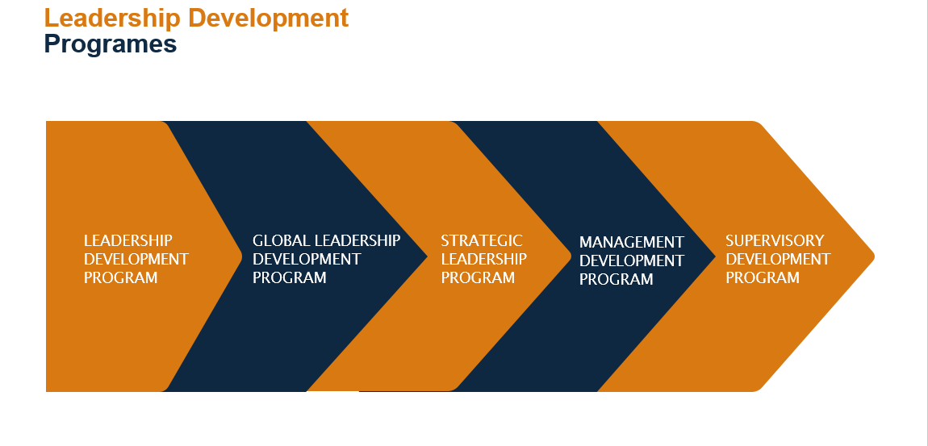
NB: Please change accordingly

Training on people management
Experienced in talent review and succession planning, performance management, reward and compensation management, employee relations and engagement and union management, strategic HR resource management, HR planning and development, organizational design, workforce planning and development, and competency-based assessment.

Talent Search and Assessments
We help organizations attract, assess, and retain top talent through executive and key talent search, talent mapping, assessment and profiling, onboarding support, and career planning, pre-employment review ensuring the right people are positioned for both immediate impact and future growth.
Consultancy replace by / Advisory and Change/
Our expertise includes strategy formulation, organizational transformation, change management, project management, leadership and young talent development, SME development, functional and technical capability building. By working closely with our clients, we deliver tailored solutions that address real business challenges and create lasting value.
Board and senior management support as trusted advisor and continuity of strategic guidance.

Coaching and Mentorship
One-to-one and team coaching for senior leaders working through transitions, expansion, restructuring, or performance challenges. We provide specialized services in coaching managers, coaching leaders, 360 assessments, career consultation and leadership development.

Organizational Transformation

Strategy alignment, structure design, change management, and cultural transformation corporate governance and functional transformation. We are usually engaged through implementation, which is the phase where these programs tend to come apart if a firm is not careful.
Organizational transformation programs
Organizational strategy and goals formulations
Compliance and risk management
Reward and compensation formulation
Employees experience survey and action plans
Cultural transformation and policy formulation
Organizational design and change management
Business model transformation including service and product development and design.

The kinds of problems clients bring us /Please bring it to the front/
- Organizational restructuring that needs to land without breaking the business.
- A leadership pipeline that is thinner than it should be.
- Difficulty attracting, retaining, or developing the right talent.
- Inconsistent culture or low engagement across teams.
- Compliance, governance, or risk gaps surfacing as the business scales.
- Rapid growth outrunning the systems and structure that were supposed to support it.
“Please omit 18+ years 1 business day response and integrated practices”

Closing CTA

Book a call
If any of this matches a problem on your desk, book a call. We spend the first session understanding the business before we propose anything.
CTA: Book a discovery call

Trading Page

Hero
Headline: Trading and Supply
Header: Genuine products. Every time.
Subhead: Sourcing and distribution for fleet, construction, healthcare, and infrastructure buyers across Ethiopia and the region.

Our approach

Introduction
Our trading work is concentrated in product categories where buyers in Ethiopia have a hard time finding consistent, technically capable suppliers. Most shipments come through our operations in the Djibouti free zone, which keeps logistics costs and lead times manageable. We sell to fleet operators, contractors, hospitals, government buyers, and distributors.

Product Lines
//We need pictures//

Electric Vehicles
Passenger and commercial EVs for fleet buyers, distributors, and businesses preparing for the energy transition in East African markets.
After-sales support coordination

Construction Machinery
Excavators, loaders, and supporting equipment for construction firms, contractors, and industrial projects. We source from manufacturers and supply in Ethiopia and the region.
Spare parts and lubricants

Sanitary Equipment
Sanitary ware and fittings for construction projects, real estate developers, and institutional buyers and retailers.

Medical Equipment
Diagnostic and clinical equipment for hospitals, clinics, and healthcare institutions. We select equipment with regulatory and clinical standards in mind.
Regulatory clearance support : Omit

Why buyers work with us/ instead of Operating from Djibouti Free zone/
- Direct relationships with manufacturers rather than working through layered distribution chains
- Djibouti free zone operations for faster and cheaper regional logistics
- Order sizes from single units to large fleet purchases

Omit: Djibouti freezone operations

Closing CTA

Request a quote
Send us the specifications, the quantity, and your timeline, and we will come back with options and a price.
CTA: Request a quote

Contact Page

Hero
Headline: Get in touch
Subhead: Send us a note. We respond to inquiries within one business day.

Contact Details
Phone: +251 951 77 97 77 | +251 986 11 18 11
Email: info@antragroup.et (needs confirmation, see notes)
Address: Africa Avenue, Rayuma Building, Office 912, Kirkos Sub-City, Addis Ababa, Ethiopia (needs confirmation, see notes)

Contact Form Fields
- Full name
- Company or organization
- Email
- Phone number
- I am interested in: (dropdown: Consultancy, Trading, Both, Other)
- Tell us about your project
- Submit button label: Send message

Closing Line Under Form
We do not share contact details with third parties.

Notes for the Client Call
Items in the brief that still need confirmation or a strategic decision before the website goes live.

1. The address contradicts itself
The brief says "Kirkos Subcity, Africa Avenue, Rayuma Building." Kirkos and Bole are two different sub-cities. Africa Avenue (Bole Road) sits in Bole. Confirm which sub-city is correct. The draft uses Bole as the more likely answer, but verify.

2. The email is incomplete
The brief shows "@ANTRAGROUP.ET" with no prefix. The draft uses info@antragroup.et as a placeholder. Get the actual address.

3. Strategic tension between consultancy and trading
Premium consultancy clients can read a trading sideline as a distraction, or worse, as a conflict of interest. Will the consultant recommend a transformation that needs equipment they happen to sell? The copy keeps the two practices visually and narratively distinct, but ask the client whether they have considered sub-branding the trading arm under a separate name, or at minimum keeping the two practices on parallel tracks rather than fully interwoven. This is the biggest issue in the brief.
//Let’s put Management consultancy as a head and trading as a subhead

4. Differentiation claims still need proof
The rewrite leans on the eighteen years of experience and the Djibouti Freezone access, because those are the only specific, defensible claims in the brief. To get the website past the credibility threshold, the client needs to supply real proof points: named past engagements (even anonymized), client logos, sector case studies, results in numbers. Without those, the site still asserts credibility rather than showing it.
Notable mentions: Coca-cola company, Moenco, Ethiopian airlines,

5. The competitor list is too thin
Rework, People First, Talent First, and Hagbes are very different in scale, segment, and offering. If the client wants to position seriously, they need a sharper competitive map. Worth a follow-up conversation.
//Ethio-jobs, Dolittle

6. The two missions read as if written by different teams
The rewrite unified the voice. Long term, the parent brand probably needs one mission statement that explains why a single company holds both practices, otherwise the website risks looking like a holding page for two unrelated businesses.

7. SEO is weak as written
"Enabling Growth and Transformation" is a tagline, not a keyword. For lead generation, the site needs optimization around terms people actually search in Ethiopia and the region: "management consulting firms Addis Ababa," "leadership training Ethiopia," "construction equipment supplier Ethiopia," "electric vehicle importer Ethiopia," and so on. Worth a quick keyword pass before launch.
Management Consultancy : To be a trusted partner of choices for organizational transformation, leadership development, Strategy & business alignment, training, coaching and mentoring, talent search and consultancy services in Ethiopia & regional markets
Trading: Establishing the Free Zone as a preferred source of suppliers for selected products for Ethiopia and regional markets.

8. No portfolio or case study section in the brief
For a consultancy positioning around credibility, this is a missed opportunity. Even a "Selected Engagements" section with anonymized client work would lift trust significantly. Recommend adding this as a phase-two addition once they have client permission to publish, but flag it now.
We are currently partnering with one of Ethiopia’s largest and most respected big construction company to support its organizational transformation journey. Our engagement focuses on strengthening leadership capabilities, enhancing organizational effectiveness, and driving sustainable business performance through tailored consultancy solutions.

